Project Report

Project 1

Home screen with header

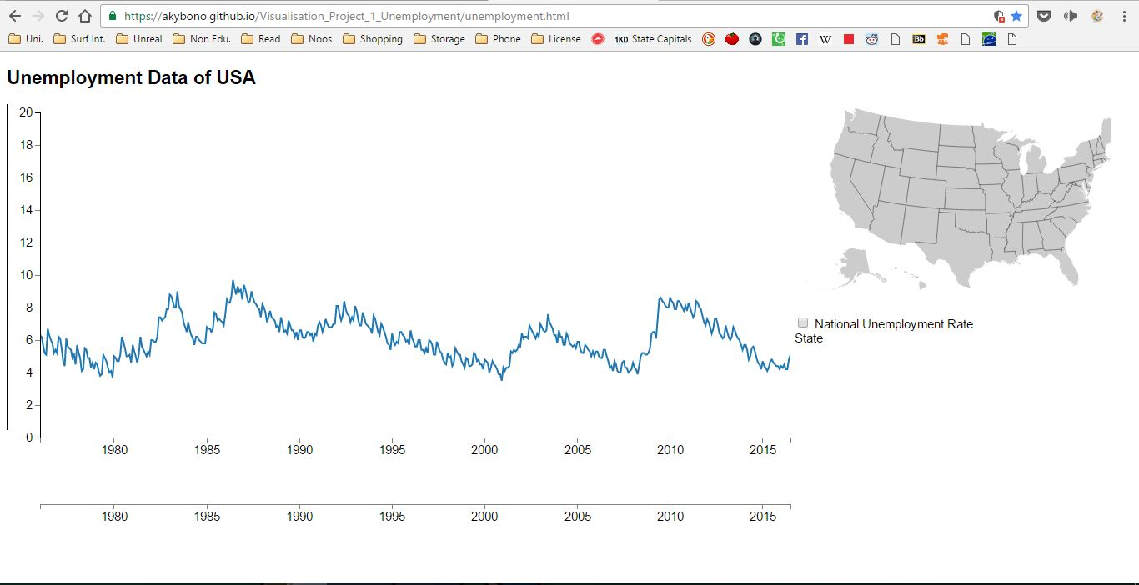

Hovering Mouse over map Gives Name of State

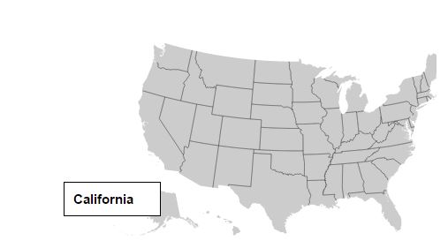

Hovering over graph line gives state name

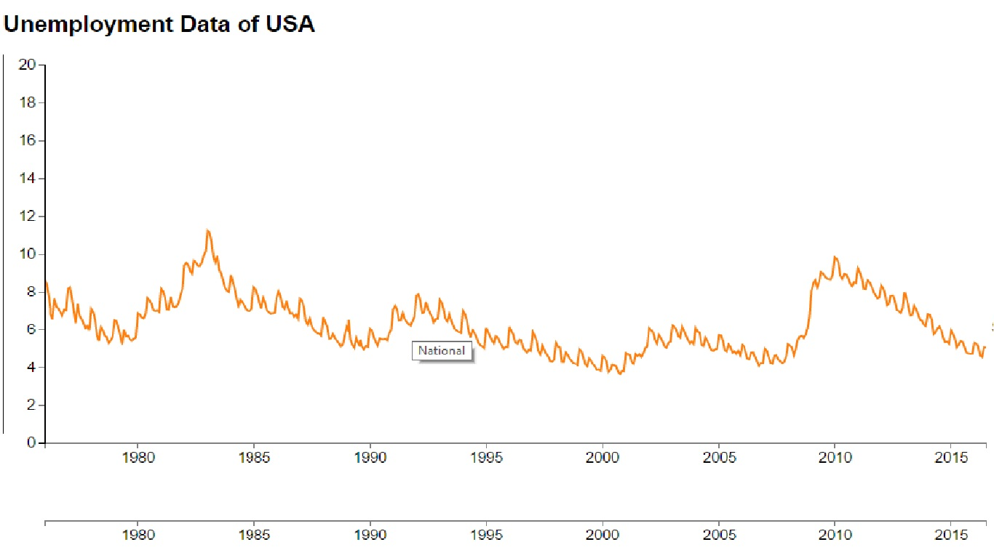

Every Selection Provides Unique Color

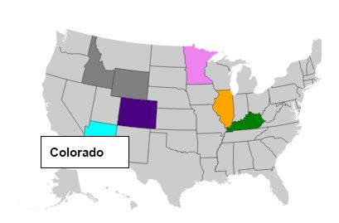

Multiple selection immediately reflected on graph

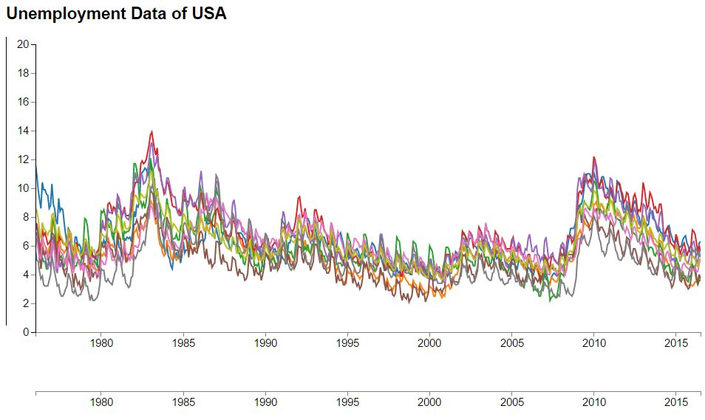

Scroller functionality with zoom and compare

